1. When the gate voltage reaches the threshold voltage, the ideal switch would spike up and slowly level off, while a real MOSFET would always be slowly ramping up as the gate voltage increases. The ideal switch would also have no leakage current, while a real MOSFET would have a small amount of leakage current.

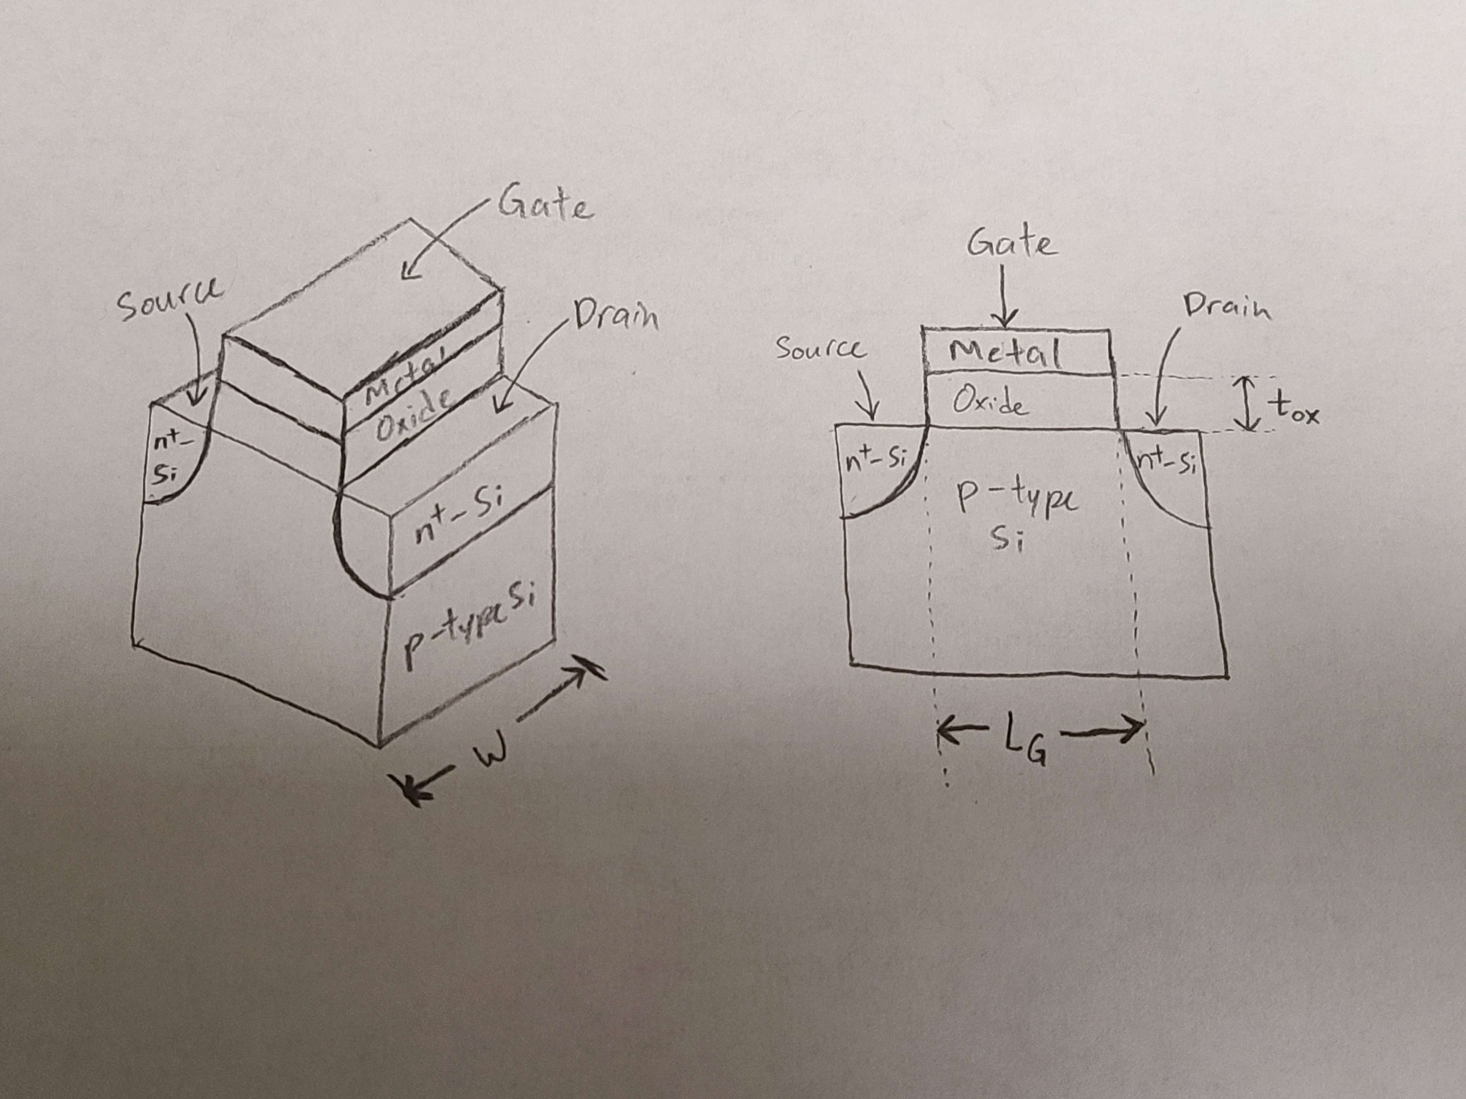

1. Between 0.5V and 1.5V
2. Since the gate-source voltage is greater than the threshold voltage (3V > 0.8V), the MOSFET is in enhancement mode.
3. I think that Sam Altman’s 7 trillion dollar chip dream is a bit unrealistic. There used to be a strong emphasis on software and the things we can create, but Altman is bring forth the idea that the hardware that supports the software is behind and not keeping up with the demand. While I don’t think there is not much to improve on, especially with the tedious manufacturing process, I think his idea is good in the sense that it brings attention to hardware.